**Undeserved persona use case**: Jeff is a 41 year old dad of two who works at a fast food restaurant. He doesn’t consider himself technologically proficient and he’s generally busy with a limited amount of time to spare. He would like to be able to shop for cheap and quickly.

**Prototype**: We used Balsamiq to create our prototypes and screen transition diagrams. Balsamiq gave us basic mockups we could improve upon which easily allowed us to represent how this Amazon Coupons application would look like on a smartphone screen. The prototype file should be submitted with this document.

**Design Decisions:**

**Financial Attentiveness**

Underserved:

The undeserved persona needs to maintain a strict budget and keeps all receipts. As he actively prioritises his essential expenses anything that helps him with the math and keeping a record of what he bought is something he appreciates and needs.

Mainstreamer: Our mainstreamer doesn’t keep a very strict budget and often doesn’t know exactly how much money they have. However, they do appreciate the added convenience of the coupons automatically being deducted from their order summary and cart so they know how much to pay.

**Device Age**

Underserved:

The underserved persona owns an old Android phone that is four years old. In addition, he shares this phone with his family. He would like to be able to maintain multiple accounts on the same device.

Mainstreamer: Our mainstreamer has a fairly new iPhone and in fact usually gets the latest updates. They have their own device.

**Device Access**

Underserved:

The underserved persona shares his mobile phone with his children, and would like to be able to maintain some privacy despite this.

Mainstreamer: Our mainstreamer has their own device, as does everyone in their own family.

**Technological Experience**

Underserved:

A basic user of smartphones and laptops. He does not feel confident in his abilities to handle different problems or confusing prompts.

Mainstreamer: Our mainstreamer feels pretty confident in their ability to use technology.

Case by case justifications:

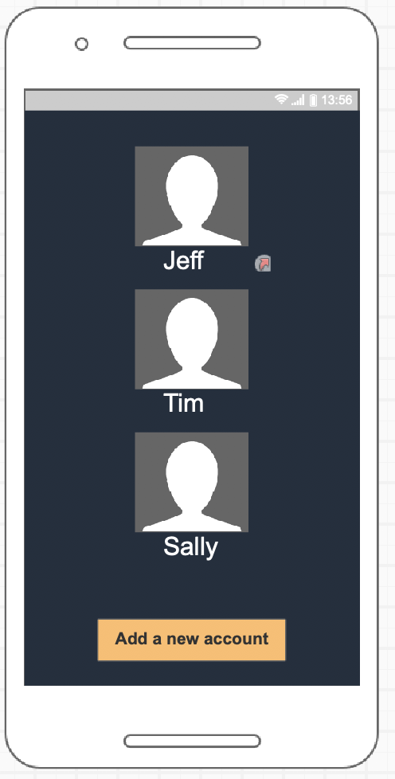

Underserved persona use case: Our persona Jeff shares a mobile device with other members of his family, such as his children Tim and Sally. Jeff clicks on his name and is taken to a screen where he can then verify his identity by entering a password.

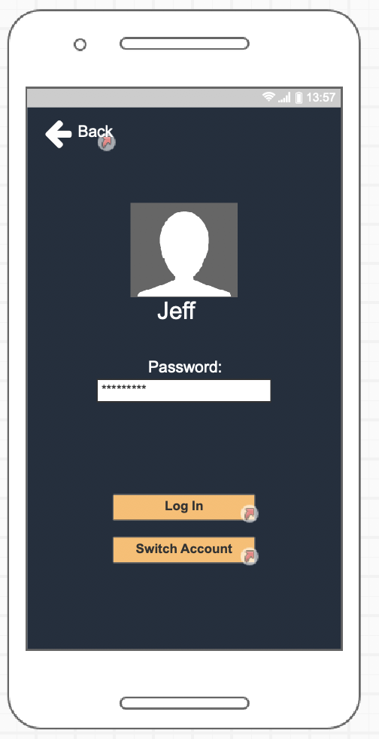

Undeserved use case: After Jeff verifies his identity, he can then log into the website. Alternatively, if the user had actually been Sally or Tim and they had clicked on Jeff’s name by mistake and actually intended to log into their respective accounts, they can click on the “Switch Account” button.

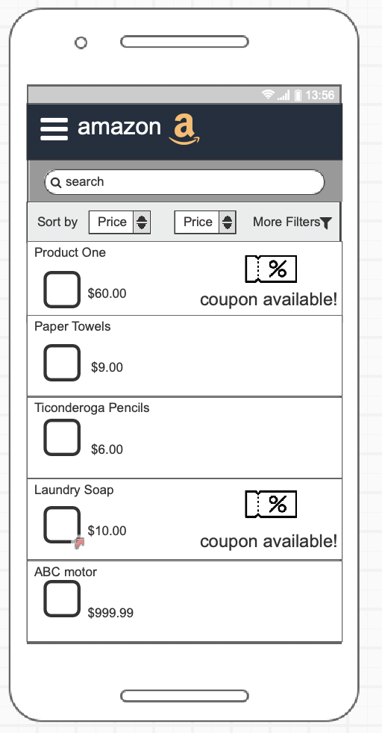

Undeserved use case: After Jeff logged in his own account, he can now start searching products, then in this product list, Jeff will clearly see all the related results even there are some sorting methods could be applied. Most importantly, the coupons information what Jeff really cares about listed on the right side and easy to be found.

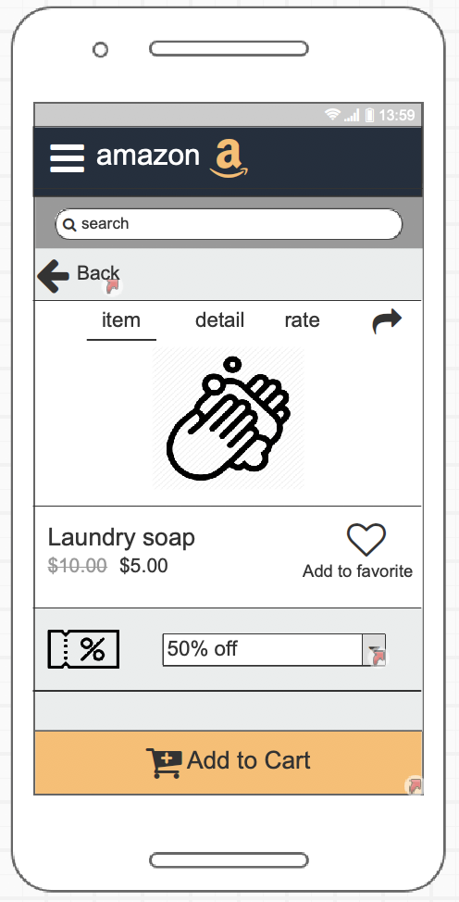

Undeserved use case: After Jeff chose the product, he will enter the product page, on this page, Jeff will find more details of the product, like ratings, photos, introductions, meanwhile, he also could choose all the available coupons on the downside, there would be another page offer Jeff to see all available coupons and make the decision. Finally, after Jeff chose the coupon, he just needs to click the button below to add item to cart, then he could go to another page.

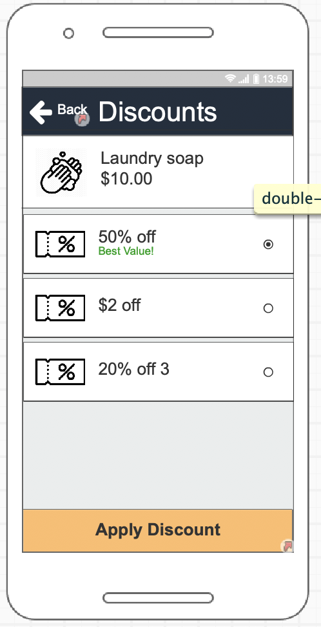

Undeserved use case: Jeff wants to know about all the ways he could potentially save money on his purchase. He wants to know any terms or conditions that coupons come with and the raw savings he can have that cuts through confusing language that is often present in bulk or percentage based discounts.

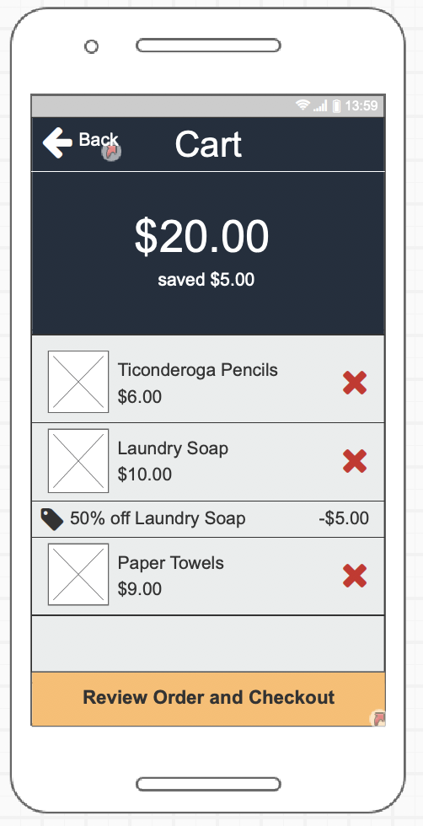

Undeserved use case: If Jeff needs to see what coupons have been applied in his cart, the calculations are automatically done for him. Jeff isn’t a huge fan of doing math so he appreciates having it cleanly laid out for him how much money he’s spending and how much he’s saving.

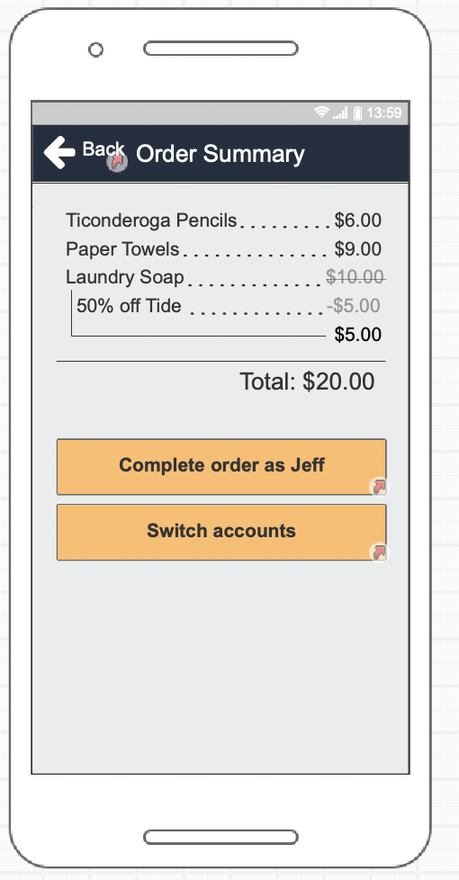

Undeserved use case: After Jeff completes his order, he is taken to a page where he can verify his order or switch his account. The order summary gives him a clearly labelled explanation of everything he bought and how much he saved.

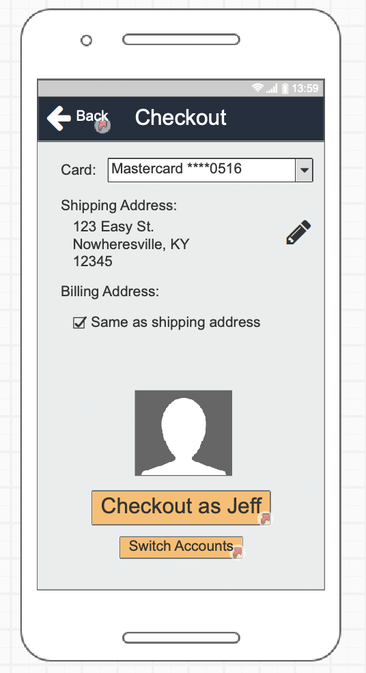

Undeserved use case: After all of this, Jeff is made sure of what he ordered and how much it cost. Feeling satisfied, he can arrive to the Checkout page and choose to complete his order by clicking on “Checkout as Jeff”.

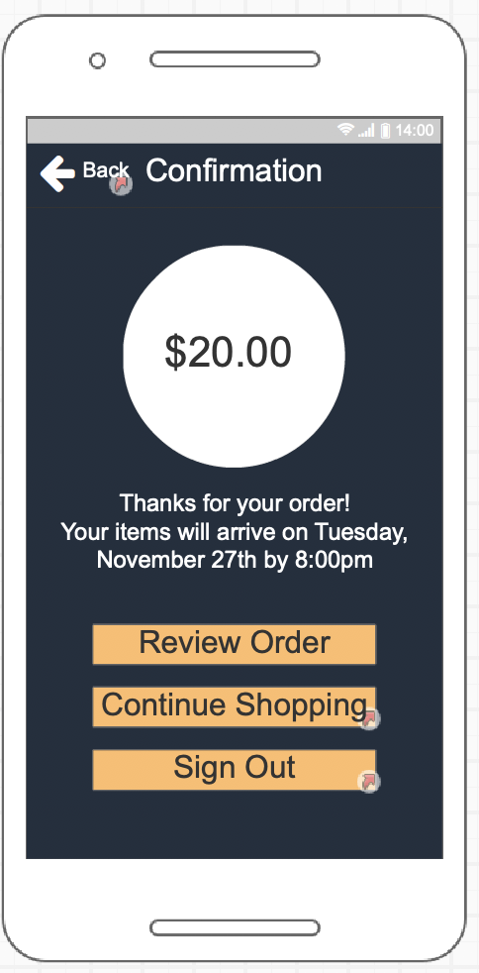

Undeserved use case: Jeff has made his order but was unsure when it would arrive. This worry is assuaged however - he sees exactly when his order will arrive and how much it had cost him. But perhaps he’s feeling like he wants to go shopping more and add some amazing coupons to his next order. If so, he can continue shopping. Alternatively, he can review his order to see exactly what items he purchased and what coupons had been applied to that.